Week 2 Lab 2 - Troubleshoot IPv4 and IPv6 Static Routing

Topology
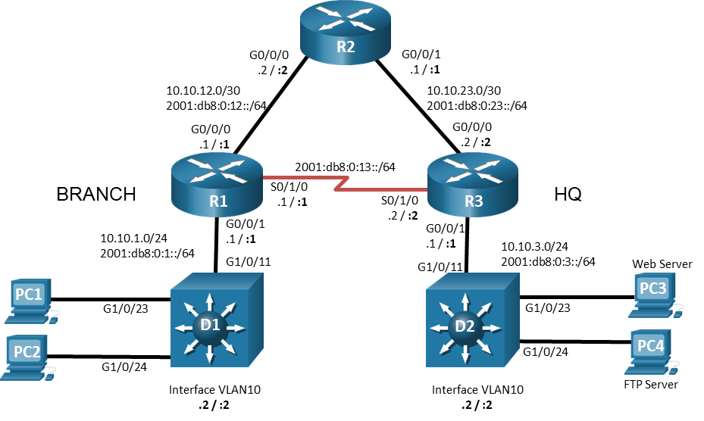

Addressing Table
Device | Interface | IPv4 Address/Mask | IPv6 Address/Prefix | IPv6 Link Local | Default Gateway
R1 | G0/0/0 | 10.10.12.1/24 | 2001:db8:0:12::1/64 | fe80::1:1 | N/A
R1 | G0/0/1 | 10.10.1.1/24 | 2001:db8:0:1::1/64 | fe80::1:2 | N/A
R1 | S0/1/0 | N/A | 2001:db8:0:13::1/64 | fe80::1:3 | N/A
R2 | G0/0/0 | 10.10.12.2/24 | 2001:db8:0:12::2/64 | fe80::2:1 | N/A
R2 | G0/0/1 | 10.10.23.1/24 | 2001:db8:0:23::1/64 | fe80::2:2 | N/A
R3 | G0/0/0 | 10.10.23.2/24 | 2001:db8:0:23::2/64 | fe80::3:1 | N/A
R3 | G0/0/1 | 10.10.3.1/24 | 2001:db8:0:3::1/64 | fe80::3:2 | N/A
R3 | S0/1/0 |  | 2001:db8:0:13::2/64 | fe80::3:3 | N/A
D1 | VLAN 10 | 10.10.1.2/24 | N/A | N/A | 10.10.1.1
D2 | VLAN 10 | 10.10.3.2/24 | N/A | N/A | 10.10.3.1
PC1 | NIC | 10.10.1.10/24 | 2001:db8:0:1::10/64 | EUI-64/CGA | 10.10.1.1  2001:db8:0:1::1
PC2 | NIC | 10.10.1.20/24 | 2001:db8:0:1::20/64 | EUI-64/CGA | 10.10.1.1  2001:db8:0:1::1
Web Server | NIC | 10.10.3.5/24 | 2001:db8:0:3::5/64 | EUI-64/CGA | 10.10.3.1  2001:db8:0:3::1
FTP Server | NIC | 10.10.3.20/24 | 2001:db8:0:3::20/64 | EUI-64/CGA | 10.10.3.1  2001:db8:0:3::1

Objectives
Troubleshoot network issues related to IPv4 and IPv6 static routing.

Background / Scenario
In this topology, routers R1, R2, and R3 are configured for static routing. Switches D1 and D2 provide LAN connectivity for VLAN 10 for the respective locations. You will be loading configurations with intentional errors onto the network. Your tasks are to FIND the error(s), document your findings and the command(s) or method(s) used to fix them, FIX the issue(s) presented here and then test the network to ensure both of the following conditions are met:
        - the complaint received in the ticket is resolved
        - full reachability is restored
        - document your complete troubleshooting solution to Moodle for grading
        - enter your unique PKA code once the file is at 100%.
        - You must log into each activity with your own name and student email as before.

Instructions

Trouble Ticket 1
Scenario:
An FTP Server was recently added to the HQ network. The FTP Server is accessible from all devices in the HQ network. Branch network hosts PC1 and PC2 are able to connect to the Web Server but are unable to connect to the FTP Server using IPv4.
Note: Web or FTP services are not required on the PCs.
Use the commands listed below to load the configuration files for both trouble tickets:
- PC 1, PC 2, FTP Server, and Web Server should be configured with the addressing listed in the Addressing Table.
- Passwords on all devices are cisco12345. If a username is required, use admin.
- The * on this activity means there is a connectivity test required from PC1 to the FTP server etc

Trouble Ticket 2
Scenario:
A WAN connection through R2 was recently added to increase the bandwidth that is available between the branch and HQ. It was decided to keep the dedicated T1 connection from R1 to R3 as a backup link for IPv6 traffic. Users at the branch have been complaining that data transfer speeds to PCs at HQ seem to be slow; however, downloads seem to be fine. Students can test for connectivity from Branch users to HQ devices. Those results should be successful. However, it is more the round-trip path that is important here i.e. does the packet take the desired path. Verify this from executing a traceroute from R1 to the Web Server.
- PC 1, PC 2, FTPServer, and WebServer should be configured with the IPv6 addressing listed in the Addressing Table. It is not necessary to configure the IPv4 addresses.
- Passwords on all devices are cisco12345. If a username is required, use admin.
End of document

